**Project: MSS60**

**Module:** **Antiruckel**  **function**

**Table**

Change documentation 3

8. Antiruckel function 4

8.1 General 4

8.2 Calculation speed gradient for AR 4

8.3 Activation Condition of AR 4

8.4 States of AR 5

8.5 Ignition angle intervention of the AR 6

8.6 Data of AR 6

# Change documentation

Version: 1.0 02.11.2004

Initial creation

# 8. Antiruckel function AR

# 8.1 General

With a rapid transition from thrust or low partial load to higher load ranges, vibrations in the drive train can occur in the lower speed range. The anti-ruckel function of the MSS52 counteracts these jerk oscillations by detecting the vibrations of the drive train and damping them by means of phase-correct moment interventions.

During a positive speed gradient (increasing motor speed ) the emitted motor torque is reduced by means of a moment-intervention (ignition angle late adjustment ).

# 8.2 Calculation of speed gradients for AR

The calculation of the speed gradient "d_n_segment" is based on the segment speed "n_segment" and is doneevery 120°KW again. The segment speed is calculated from the duration of a segment ( 60°KW before OT to 60°KW according to OT ).

Formula:

d_n_segment(t) = ((n n_segment(t) - n_segment(t-120°) / t_segment(t)

+ d_n_segment(t-120°) / 2

Speed gradient = mean value from the speed difference of two segments, normalized to

Upm/sec and the previous gradient

# 8.3 Activation Condition of the AR

To activate the antiruckel function, the following conditions must be met:

B_AR = B_TL ; Operating state partial load

and tmot K_AR_TMOT_MIN ; Motor temperature greater threshold

and K_AR_NMIN n K_AR_NMAX ; Speed within range

and K_AR_RFMIN tl K_AR_RFMAX ; Load within range

and ( K_AR_VMIN v K_AR_VMAX ; Speed within range

or B_V_ERROR ); as long as V detection is error-free

and S_GANG ; Force in place

; ( not yet active in the mooment )

The activation condition is summarized for the following documentation on the condition B_AR.

B_AR = 1 : Condition met

B_AR = 0 : Condition not met

# 8.4 States of AR

Figure 8.1: State machine of the Antiruckel function

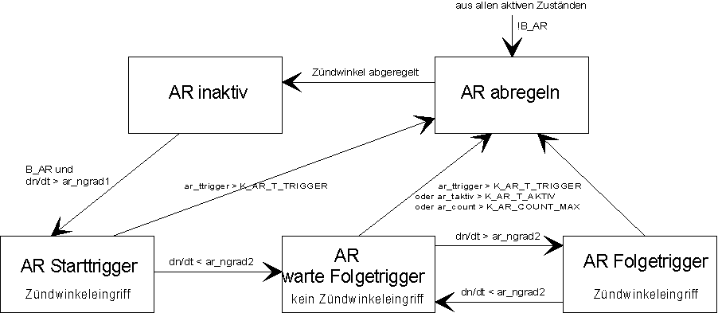

As long as the condition B_AR is not met and the ignition angle interventions of previous AR regulations are regulated, the AR is "inactive" in the state.

If the condition is B_AR met, the AR changes to the "Start Trigger" state as soon as a speed gradient greater than the trigger threshold ar_ngrad1 ( from characteristic field KF_AR_NGRAD1 = f( n, tl )) is detected.

If the speed gradient falls below the value ar_ngrad2 ( from characteristic field KF_AR_NGRAD2 = f( nt, tl )), the AR changes to the state "Wait for follow-up triggers". If this gradient threshold is not exceeded within the time K_AR_T_TRIGGER after the start triggering has been detected, it is concluded that there is no jerking vibration and the AR changes to the "regulate" state.

In the "Wait for Follow Triggering" state, no AR ignition angle intervention is active. As soon as the speed gradient exceeds the threshold ar_ngrad2 again, the AR changes to the "follow-on triggering" state. If this threshold is not yet reached, the AR enters the "regulate" state as soon as one of the following conditions is detected.

Time since last state transition > K_AR_T_TRIGGER

Total time of AR active > K_AR_T_AKTIV

Number of triggers > K_AR_COUNT_MAX

# In the "Follow-up Triggering" state, an ignition angle intervention is again active. A change to the "Wait for follow-up triggering" state occurs when the speed gradient is again lower ar_ngrad2 and the conditions for terminating the AR are not yet met.

In the"abreglen" state,the AR should be terminated. Any existing ignition angle interference is controlled. It then switches to the "inactive" state.

For all active states, as soon as the condition B_AR is no longer met, a change to the "regulate" state occurs.

# 8.5 Ignition angle intervention of the AR

Figure 8.2: Calculation of the ignition angle offset



# 8.6 Data of the AR

Variable of AR:

|  |  |  |  |
| --- | --- | --- | --- |
| **Name** | **Importance** | **Type** | **Resolution** |
| ar_mdroh | UNfiltered turning torque offset of the AR | Sw | 1/10 °KW |
| ar_grad1 | Gradient threshold for AR triggering | Sw | 1 Upmups/s |
| ar_grad2 | Gradient threshold for AR follow-up triggering | Sw | 1 Upmups/s |
| ar_taktiv | System time at which the AR was last activated | Uw | 1 ms |
| ar_ttrigger | System time at the last ARtriggering | Uw | 1 ms |
| ar_count | Number of triggers | Uc | 1 |
| ar_zustand | State variable of the AR ( only 1 bit set at a time )  Bit 0: AR inactive  1: Start trigger detected  2: wait for follow-up triggering  3: Follow-up triggering detected  4: Unregulate AR interventions | Uc |  |
| ar_md_offset | Ignition angle offset of the AR | Sw | 1/10 °KW |

Application data of the AR:

|  |  |
| --- | --- |
| **Name** | **Importance** |
| K_AR_TMOT_MIN | lower temperature threshold for AR |
| K_AR_NMIN | lower speed threshold for AR |
| K_AR_NMAX | upper speed threshold for AR |
| K_AR_RFMIN | lower filling threshold for AR |
| K_AR_RFMAX | upper filling threshold for AR |
| K_AR_VMIN | lower speed threshold for AR |
| K_AR_VMAX | upper speed threshold for AR |
| K_AR_T_TRIGGER | max. time period for the next triggering |
| K_AR_T_AKTIV | max. active time of the AR |
| K_AR_ANZ_TRIGGER | max. number of triggers |
| K_AR_MDB1 | Ignition angle change limitation for AR late adjustments |
| K_AR_MDB2 | Ignition angle change limitation for AR control (early ) |
| KF_AR_NGRAD1 | Gradintenthreshold for start triggering = f( n,rf ) |
| KF_AR_NGRAD2 | Grad intenate threshold for follow-up triggering = f( n,rf ) |
| KF_AR_MD | Ignition angle offset of the AR = f ( n,dn/dt ) |